AI ASSISTANT CODING
ASSIGNMENT-12
NAME: THRISHALA JAKKARAJU
HALLTICKET:2303A51514
BATCH:22

Task Description -1 (Data Structures – Stack Implementation with AI Assistance)
- Task: Use AI assistance to generate a Python program that implements a Stack data structure.

Instructions:
Prompt AI to create a Stack class with the following methods:
- push(element)
- pop()
- peek()
- is_empty()
- Ensure proper error handling for stack underflow.
- Ask AI to include clear docstrings for each method.

Code:

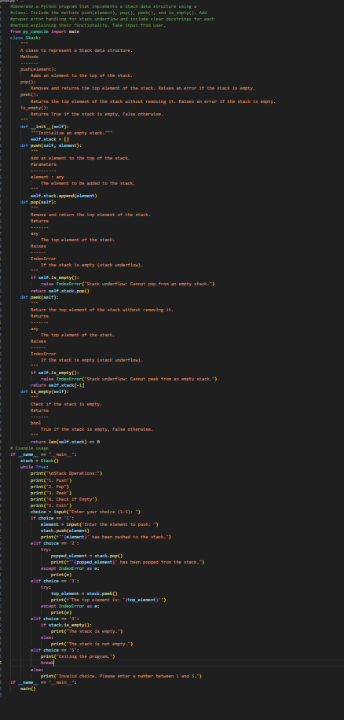

Expected Output:
- A functional Python program implementing a Stack using a class.
- Properly documented methods with docstrings.
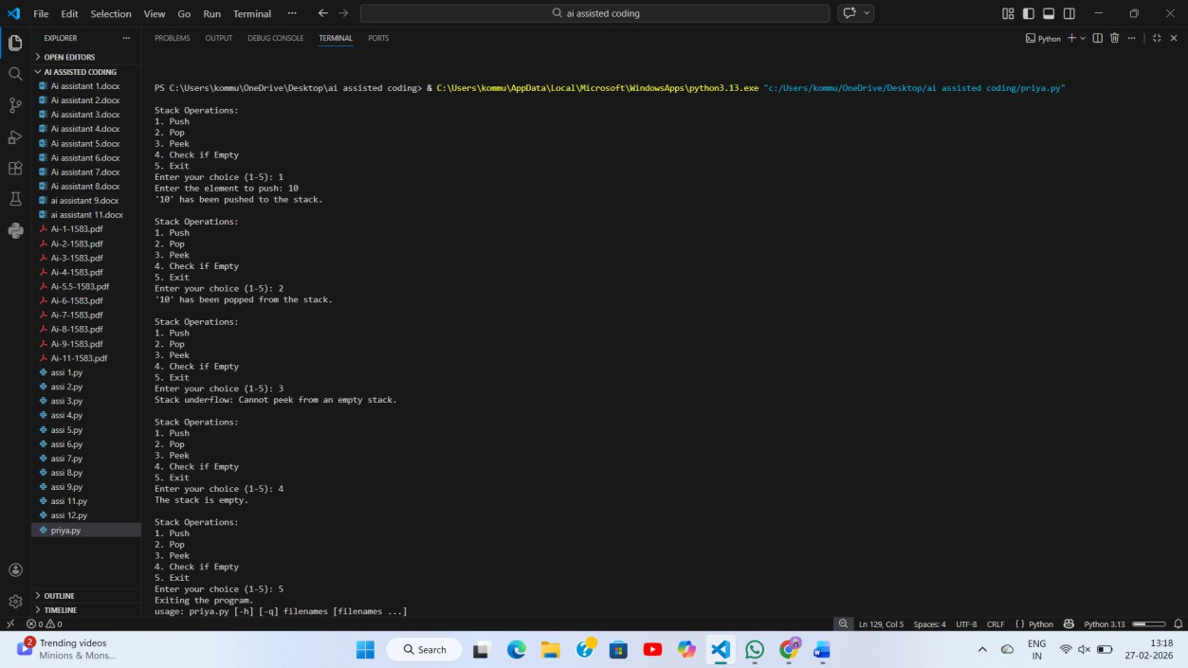

Task Description -2 (Algorithms – Linear vs Binary Search Analysis)
- Task: Use AI to implement and compare Linear Search and Binary Search algorithms in Python. Instructions:
- Prompt AI to generate:
- linear_search(arr, target)
- binary_search(arr, target)
- Include docstrings explaining:
- Working principle
- Test both algorithms using different input sizes.

Code:

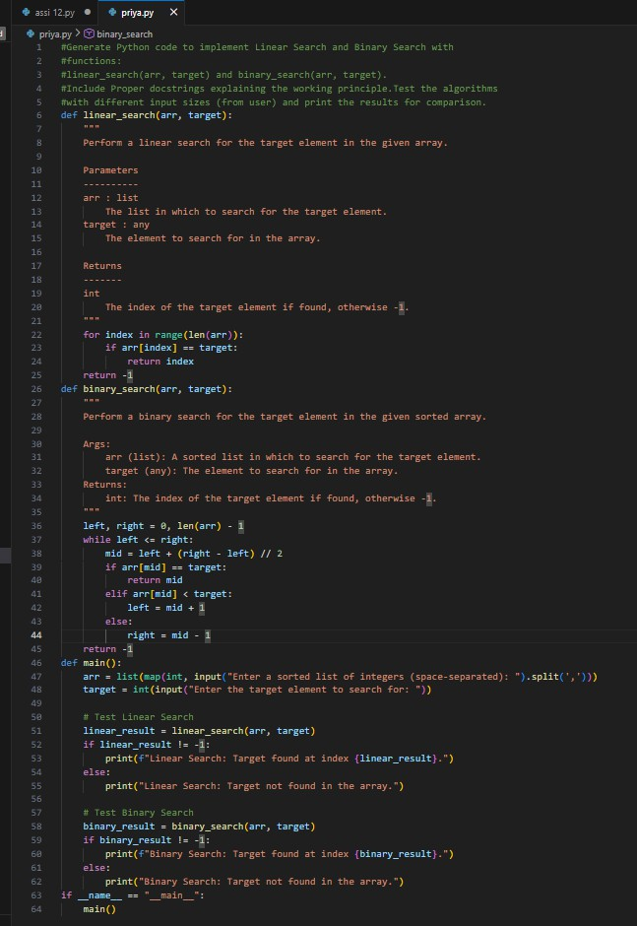
Expected Output:

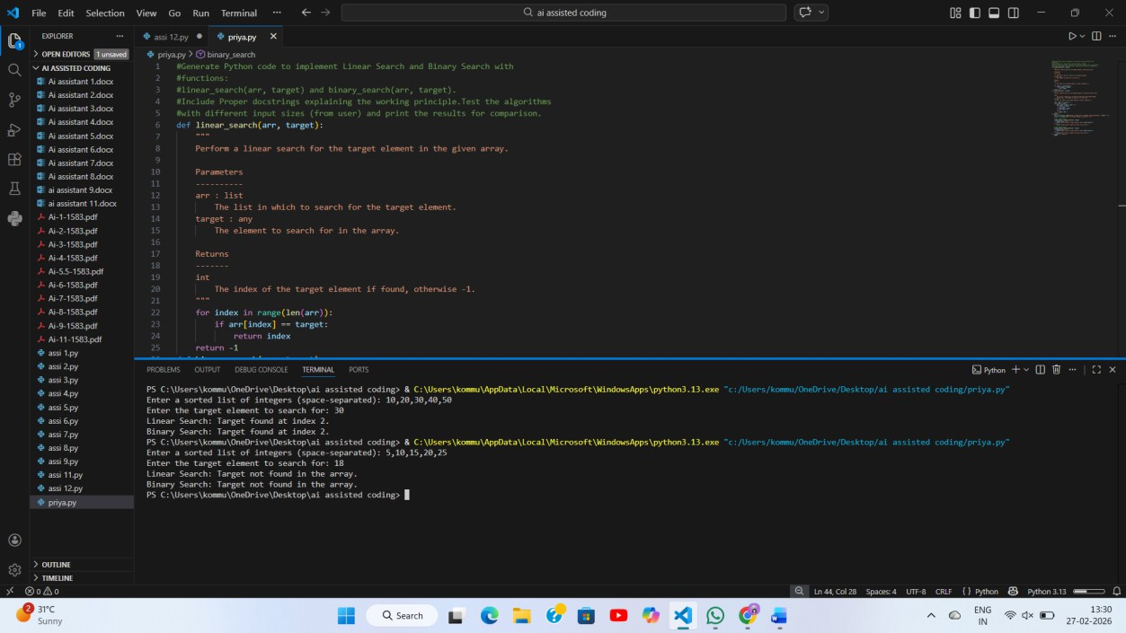
- Python implementations of both search algorithms.
- AI-generated comments and complexity analysis.
- Test results showing correctness and comparison.

Task Description -3 (Test Driven Development – Simple Calculator Function)
- Task: Apply Test Driven Development (TDD) using AI assistance to develop a calculator function.

Instructions:
- Prompt AI to first generate unit test cases for addition and subtraction.
- Run the tests and observe failures.
- Ask AI to implement the calculator functions to pass all tests.
- Re-run the tests to confirm success.

Code:

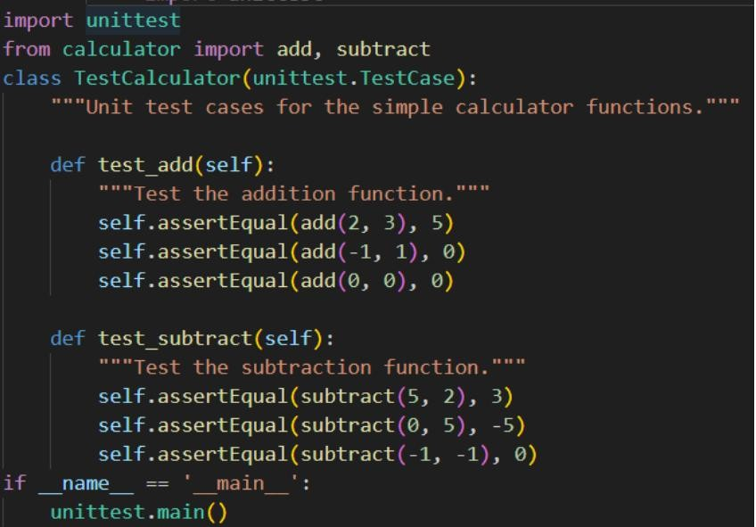

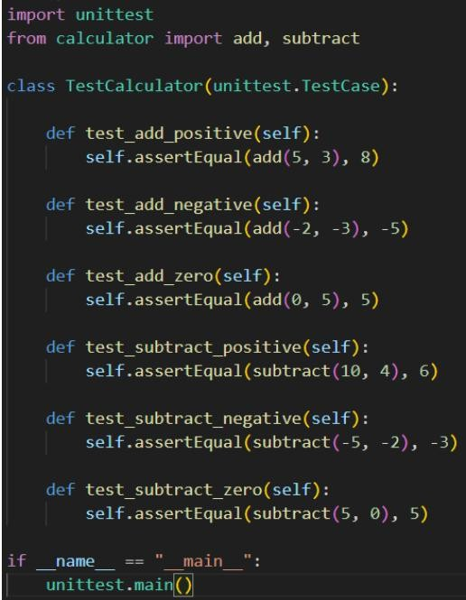

Expected Output:
- Separate test file and implementation file.
- Test cases executed before implementation.
- Final implementation passing all test cases.

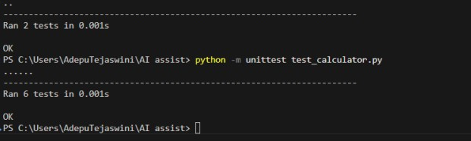

Task Description -4 (Data Structures – Queue Implementation with AI Assistance)
- Task:
Use AI assistance to generate a Python program that implements a Queue data structure.
Instructions:
- Prompt AI to create a Queue class with the following methods:
- enqueue(element)
- dequeue()
- front()
- is_empty()
- Handle queue overflow and underflow conditions.
- Include appropriate docstrings for all methods.

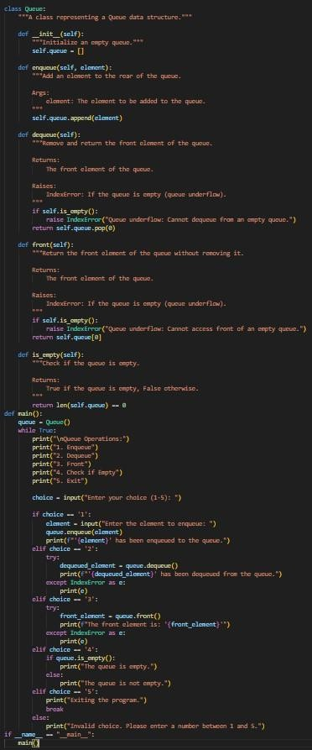

Expected Output:

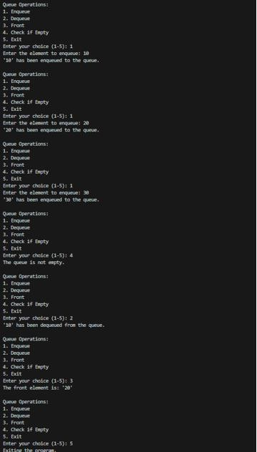
- A fully functional Queue implementation in Python.
- Proper error handling and documentation.

Task Description -5 (Algorithms – Bubble Sort vs Selection Sort)
- Task:
Use AI to implement Bubble Sort and Selection Sort algorithms and compare their behavior.

Instructions:
- Prompt AI to generate:

- bubble_sort(arr)
- selection_sort(arr)
- Include comments explaining each step.
- Add docstrings mentioning time and space complexity.

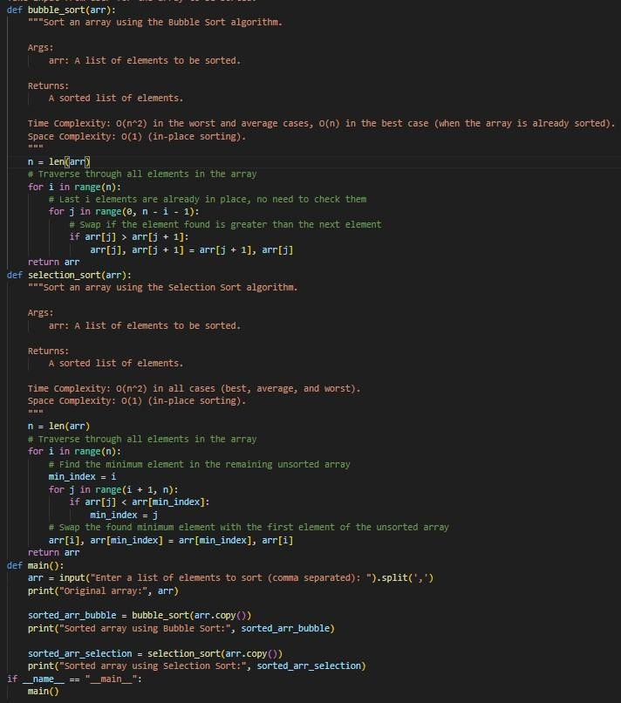

Expected Output:
- Correct Python implementations of both sorting algorithms.
- Complexity analysis in docstrings.

